R:
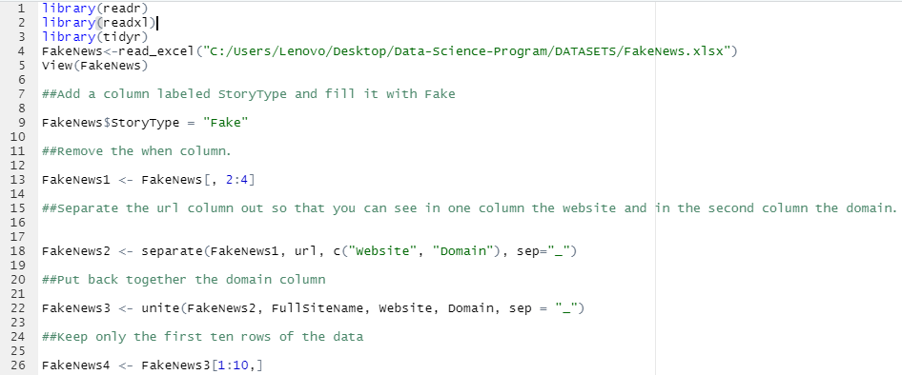

Python:
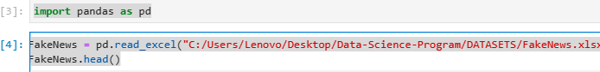



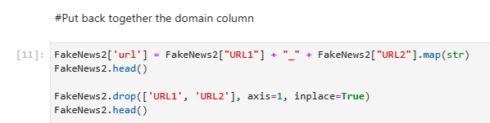


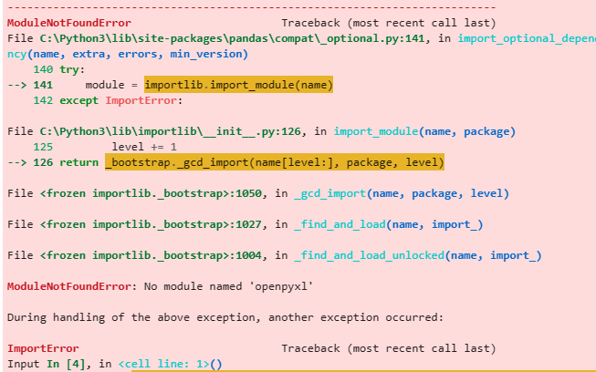
I kept getting these errors through out reason to why this practice looks choppy
I reinstalled pip and upgraded it. It didn’t make a difference.

